“STARBUCKS SALES REPORT”
STORE SALES ANALYSIS
Empowering Retail Decisions with SQL: Deep Dive into Starbucks Store Sales & Performance

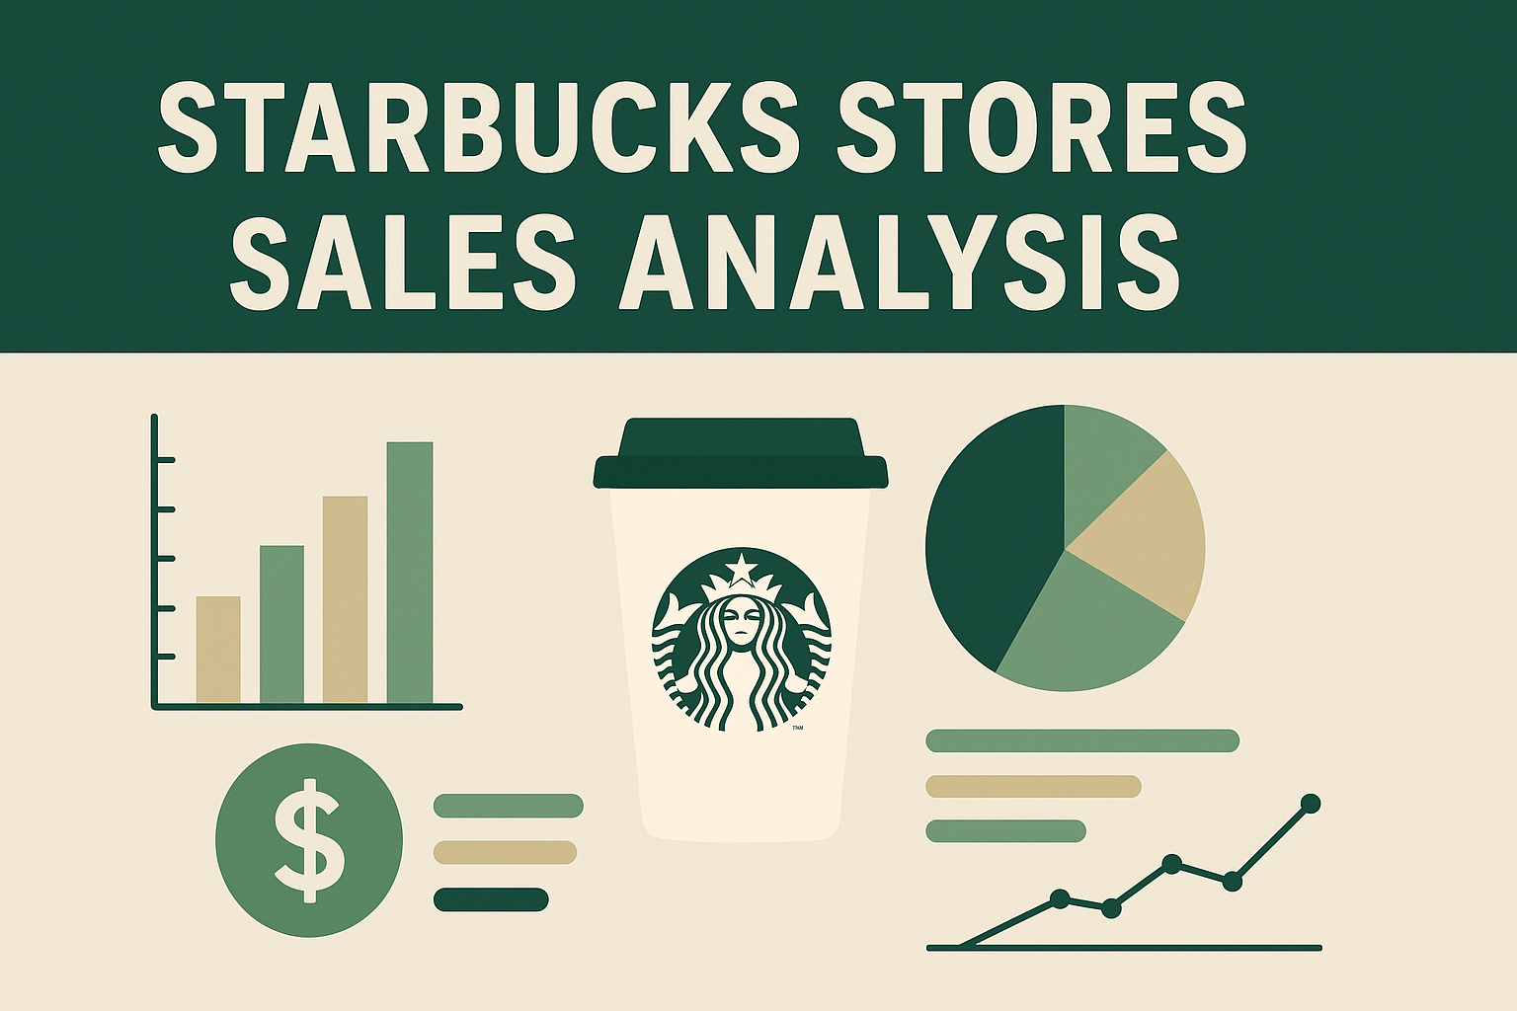

OVERVIEW
This project uses SQL-driven analysis (with Power Query as needed) to explore Starbucks store-level sales and operational data. The goal is to transform raw retail data into actionable insights for operations, store managers, regional directors, and the commercial strategy team — enabling better decisions around store performance, staffing, pricing, seasonal planning.

(Power Query + SQL Integrated project)

ASWIN SANTHOSH
PROBLEM STATEMENT
Modern retail chains like Starbucks generate massive volumes of store-level data, yet meaningful insights often remain buried in inconsistent or poorly structured datasets. Essential business decisions—such as evaluating store performance, optimizing manager assignments, improving customer satisfaction, and planning city-level expansion—are frequently made without a clear analytical foundation.

I. What’s Going On?
- Starbucks currently has store-level sales data, but it is raw, inconsistent, and difficult to analyse directly.
- Important operational insights such as city performance, manager efficiency, product-demand trends, and store health are not clearly visible.
- Duplicate entries, mismatched city names, and unstructured manager information create barriers to accurate reporting.
- Critical issues such as declining ratings, low-performing managers, or mismanaged store clusters remain hidden inside the unclean dataset.

II. Project Objective
- Clean, normalize, and convert the raw Starbucks dataset into a properly structured data model with dimension and fact tables.
- Apply analytical SQL methods (CTEs, joins, window functions, subqueries) to uncover hidden business patterns.
- Provide answers to essential business questions such as:
  - Which cities generate the highest revenue?
  - Which managers are handling too many low-performing stores?
  - Where are customers high but satisfaction low?
  - Which stores need immediate attention due to declining sales or ratings?
  - Are there store locations that are poorly placed despite good ratings?
- Empower business leaders with data-driven insights for optimizing store performance, improving customer satisfaction, and planning expansion or restructuring.

Data Description
Title: Starbucks sales Dataset
- Sample Size: ~1498 Rows, 7 Columns
- Data Types: Mixed — Numeric, Text, Date

Key Fields:
- Store_id, Num_customers
- Monthly_sales, City
- Rating, Open_date
- Manager_name

Data Cleaning Steps
- Identified and handled missing or null values in key transactional columns such as Num_customers, Rating.
- Corrected improper data types (e.g., Monthly_sales as NUMERIC, Num_customers as INT, Rating as NUMERIC , Open_date as DATE).
- Replace values (eg. Store_id “ “ = “”).
- Used TRIM and CLEAN to remove empty spaces.
- Normalized the dataset into multiple related SQL tables:
  - Cities (unique list of cities and their attributes)
  - Managers (manager profiles and assignments)
  - Stores (store-level static details)

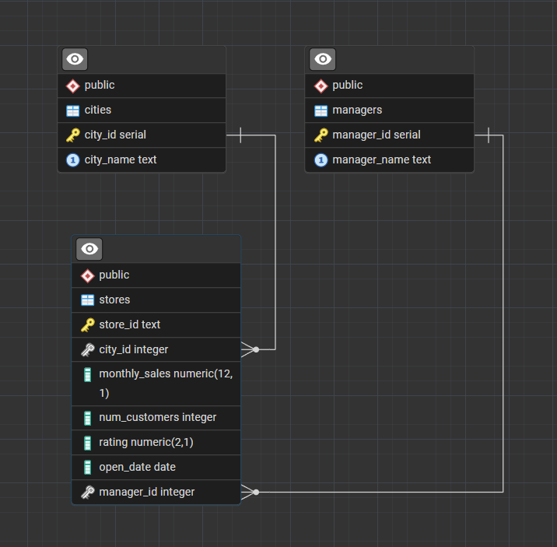

- The model follows a 1-to-many relationship pattern : Each dimension table is related to many rows in the fact table. The foreign keys in the fact table reference the primary keys in dimension tables. This structure helps in simplifying complex queries, improving query performance, and ensuring data integrity.

Category 1. Store Performance Issues
1. Underperforming Stores Compared to City Average
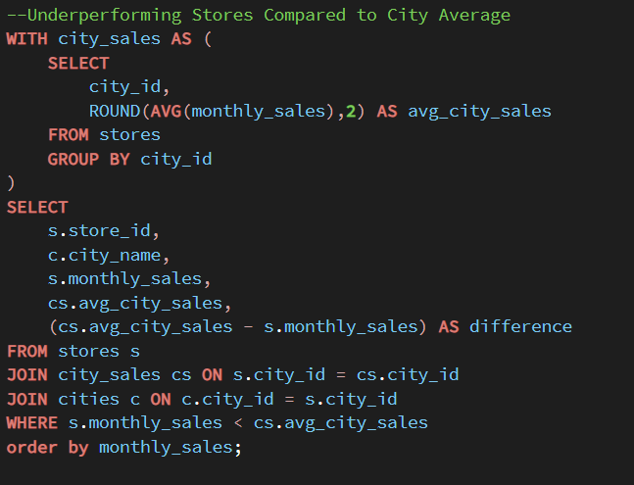
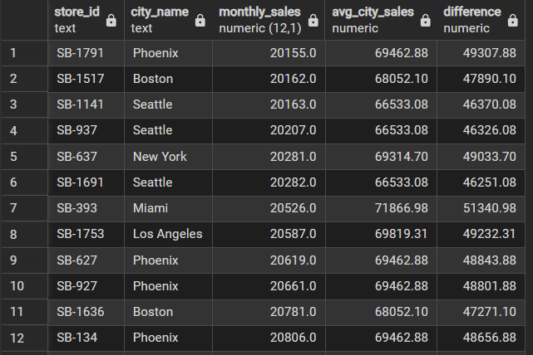
Insight:
- Stores are performing below the average sales levels of their respective cities.
- This indicates weak local marketing strategies or insufficient customer reach.
- Store location may be a major factor, suggesting low visibility or poor accessibility.

2.Older stores might have declining performance
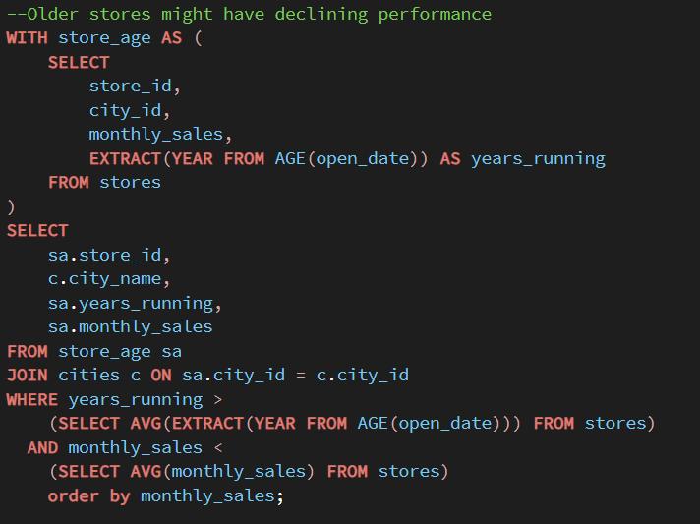
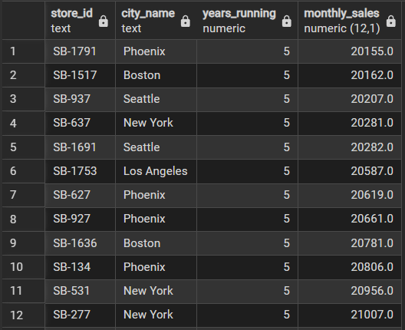
Insight:
- Stores that opened earlier may show a drop in sales or customer footfall over time.
- Declining performance can indicate aging infrastructure, outdated interiors, or reduced customer appeal.
- These stores may require renovation, marketing boosts, or operational improvements to regain performance.

3.Some stores have very low sales despite high ratings (Poor location)
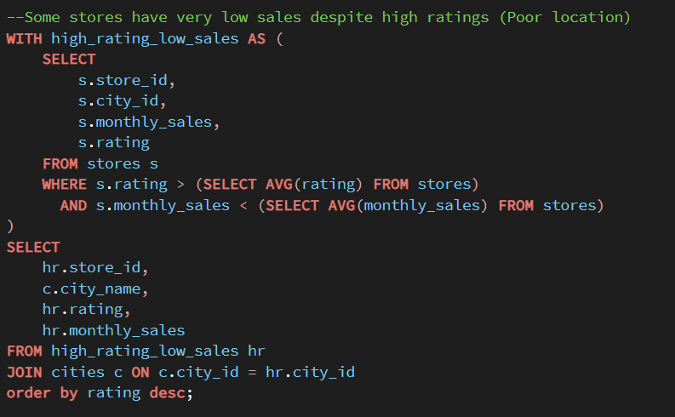
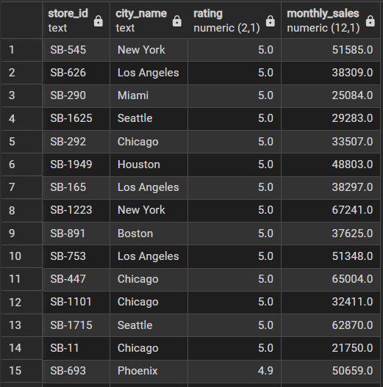
Insight:
- High ratings but low sales suggest the store is in a poor or low-traffic location.
- Strong customer satisfaction indicates service quality is good, but footfall is limited.
- These stores may benefit from relocation, better visibility, or targeted local marketing to boost sales.

4.Detect Seasonal Stores (Open Date Effect on Sales)
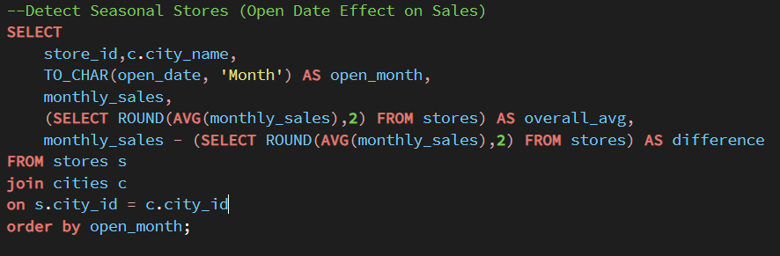
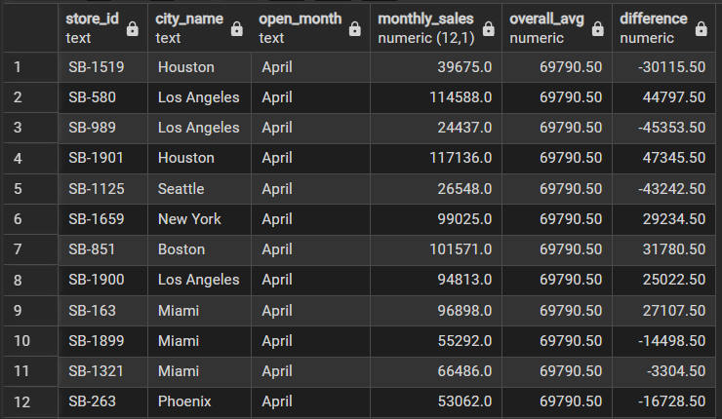
Insight:
- Store performance may vary depending on the season or month in which the store was opened.
- Newly opened stores during off-peak months may show slower initial sales growth.
- Identifying seasonal patterns helps in planning future openings and optimizing early-stage marketing efforts.
2. Customer & Rating Insights
1.High customer footfall but low store ratings
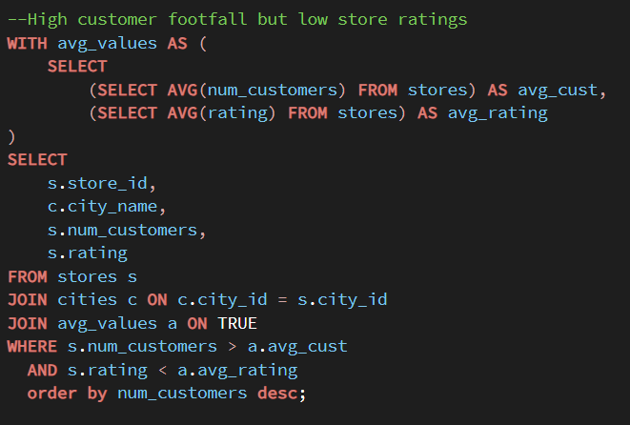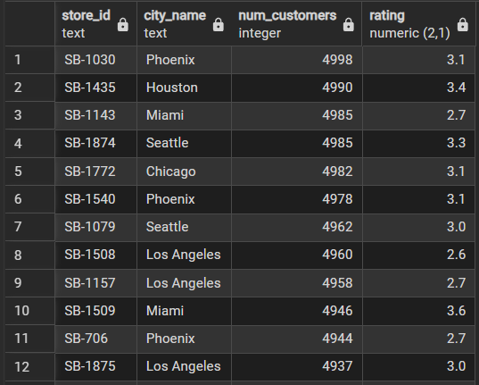
Insight:
- Stores with high customer traffic but low ratings indicate service bottlenecks or customer dissatisfaction.
- The issue likely arises from slow order processing, long wait times, or inconsistent drink quality.
- These stores risk losing repeat customers unless operational efficiency and service quality are improved.
2.Some cities have high customers but low ratings (City-level service issues)

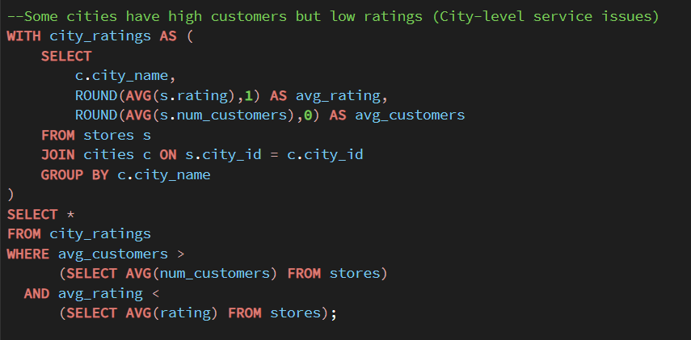

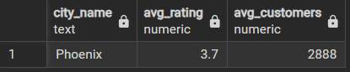
Insight:
- Cities with high customer volume but low ratings indicate widespread service or operational issues across multiple stores.
- Poor ratings suggest problems like inconsistent quality, understaffing, or inadequate customer experience city-wide.
- These cities may require city-level training, staffing improvements, and operational standardization to improve customer satisfaction.

3. Manager-Level Insights
1.Some managers handle too many low-performing stores
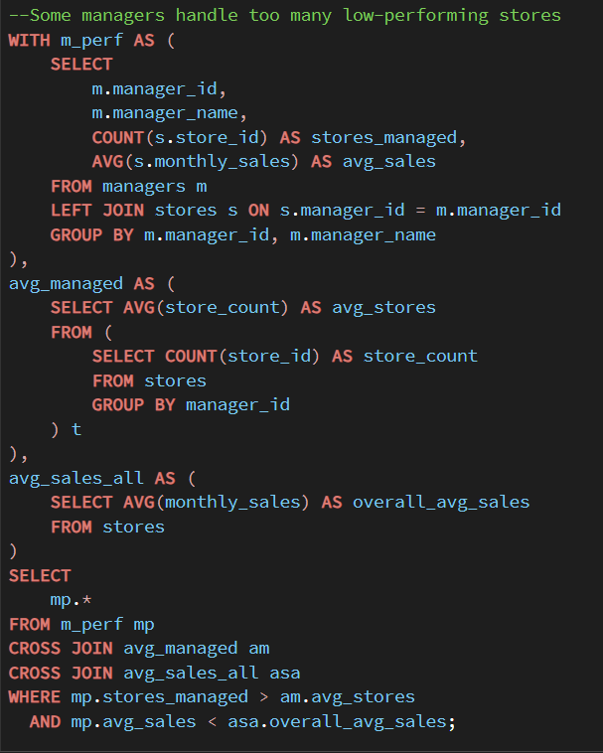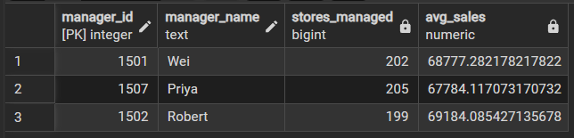
Insight:
- Identifies managers who handle more stores than average.
- Highlights those managers whose average sales are lower than the company average.
- Helps detect inefficient or overloaded managers who need support, training, or reallocation of stores.
2.Manager Performance Ranking

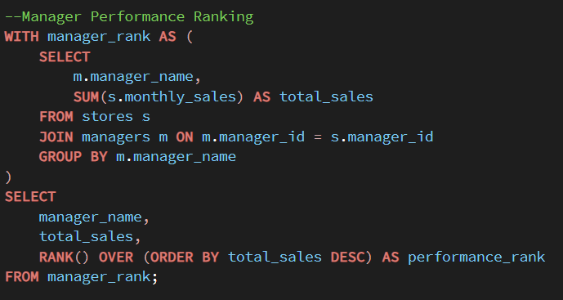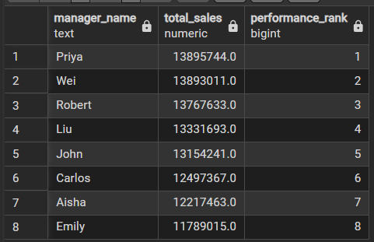
Insight:
- Ranking managers by total store sales helps identify top performers and those needing improvement.
- Shows how effectively each manager handles their assigned stores, highlighting strengths and weaknesses.
- Supports data-driven decisions for promotions, training, and store reassignments.

4. City-Level & Revenue Insights
1.City-Level Revenue Contribution
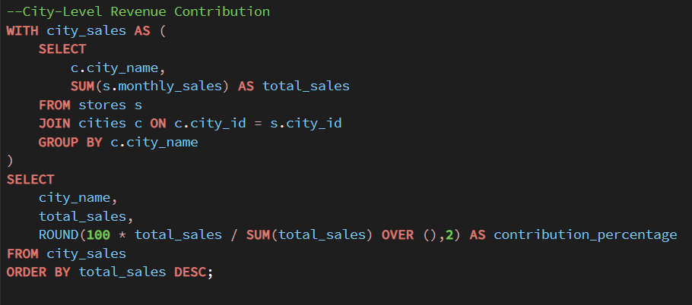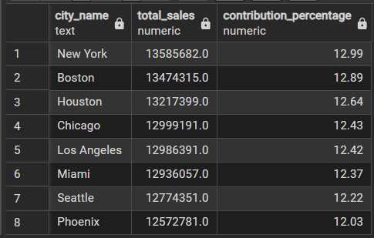
Insight:
- Shows which cities contribute the highest share of total revenue, helping identify key markets.
- Highlights underperforming cities with low revenue contribution, signalling areas needing attention or improvement.
- Helps guide strategic decisions on marketing spend, resource allocation, and future store expansion.
1.Store Performance Issues
Insights:
- Several stores are underperforming compared to their respective city averages, indicating gaps in operational efficiency or local competition.
- Older stores show signs of performance decline, possibly due to outdated layouts, reduced customer engagement, or lack of renovation.
- A few stores have high ratings but very low sales, suggesting issues related to store location, visibility, or accessibility.
- Seasonal patterns are observed where store performance varies based on the opening date, indicating that some stores function as seasonal outlets.

Recommendations:
- Conduct city-wise performance audits to identify and resolve issues causing stores to fall below average.
- Implement a renovation or modernization plan for older stores to improve customer experience and boost sales.
- For high-rated but low-sales stores, evaluate location suitability, marketing reach, and consider relocation or targeted promotions.
- Analyse seasonal trends and align staffing, inventory, and marketing efforts with peak seasons to maximize revenue.

2.Customer & Rating Insights
Insights:
- Some stores experience high customer footfall but still maintain low ratings, indicating issues with service quality, wait times, or in-store experience.
- Certain cities have consistently high customer volume but low overall ratings, suggesting broader city-level service challenges, such as staffing shortages, training gaps, or inconsistent service standards.

Recommendations:
- Conduct customer feedback analysis to identify the root causes of low ratings despite high footfall—focus on service speed, staff behaviour, and product availability.
- Improve staff training programs across stores, especially in low-rated high-traffic locations, to ensure consistent service quality.
- Introduce city-level service improvement plans, such as standardized SOPs, quality audits, and regular performance reviews.
- Use customer footfall data to optimize staffing, ensuring busy stores are adequately staffed during peak hours.
- Implement real-time feedback systems (QR codes, quick surveys) to monitor service issues and respond quickly.

3.Manager-Level Insights
Insights:
- Some managers are responsible for multiple low-performing stores, which may indicate leadership challenges, ineffective supervision, or workload imbalance.
- The manager performance ranking shows clear variations in efficiency, with top managers consistently maintaining high-performing stores while others struggle to improve store outcomes.

Recommendations:
- Reevaluate manager-to-store allocations to ensure workloads are balanced and managers are not overwhelmed, especially those handling several underperforming stores.
- Provide targeted training and mentoring for low-ranked managers, focusing on leadership skills, performance management, and customer experience strategies.
- Introduce a performance monitoring system that tracks store KPIs (sales, ratings, customer footfall) and ties them to managerial evaluations.
- Reward high-performing managers through recognition, incentives, or expanded responsibilities, reinforcing positive performance.
- For managers consistently handling low-performing stores, consider role reassignment or introducing co-managers to support turnaround efforts.

4.City-Level & Revenue Insights
Insights:
- The analysis of city-level revenue contribution shows that certain cities generate a significantly higher share of total sales, while others lag behind despite similar numbers of stores or customer traffic.
- Revenue distribution across cities highlights regional performance imbalances, suggesting differences in market size, customer purchasing power, or store operational effectiveness.

Recommendations:
- Prioritize investment and marketing efforts in high-revenue cities to maximize returns and strengthen market dominance.
- For low-revenue cities, conduct root-cause analysis focusing on customer demographics, competition, store placement, and pricing strategies.
- Implement city-specific growth plans, including targeted promotions, store revamps, or localized product offerings to boost sales.
- Regularly track city-level KPIs—sales per store, customer footfall, rating averages—to identify emerging trends and respond quickly.
- Consider reallocating resources (staffing, inventory, ad spend) based on revenue contribution to optimize overall business performance.

Conclusion

This Starbucks store performance analysis project, built on a carefully normalized SQL data model and advanced analytical queries, has revealed meaningful patterns across sales, customer footfall, store ratings, and managerial efficiency. The insights uncovered—such as underperforming locations, overloaded managers, city-level revenue variations, and mismatches between customer traffic and satisfaction—equip decision-makers with a clear understanding of where operational improvements are most needed.
By converting raw store-level data into actionable business intelligence, this project demonstrates how data-driven analysis can support smarter decisions in store optimization, resource allocation, customer experience enhancement, and future expansion planning. Ultimately, the study highlights the practical value of SQL and analytics in strengthening Starbucks' overall performance and enabling long-term, sustainable growth.

